(Name of Institution)

Outline of

Strategic Plan

2021-2023

Mandate

Aspirations
Purpose:
Vision:

Mission:

Analysis

External Environment
National

Category | Force / Trend | Implication
Political
Economic
Socio-Cultural
Economic
Technology
Environmental
Legal

Global Trends related to (mention your focus area)

Trend | Implication

Organisational Resources & Capabilities

Existing resources & capabilities critical to the organisation?

Resources | Description | Why is it critical?
Capabilities

Looking at 3 years from now, what new resources & capabilities do you need?

New Resources | Description | Why is it necessary?
New Capabilities

Stakeholder Mapping

Stakeholders
Cluster/Group | Stakeholders | Interest / Expectations

Stakeholder engagement strategies

Category | Clusters | Engagement strategies
High Influence – High Interest
Low Influence– High Interest
High Influence – Low Interest
Low Influence – Low Interest

Stakeholder map

Power
to
influence
Level of interest
High
High
Low

Stakeholder engagement

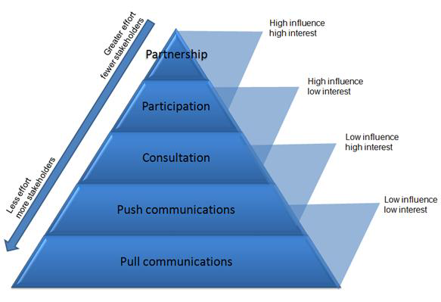

Summary of Analysis - Key highlights

Environment

Resources & Capabilities

Stakeholders

